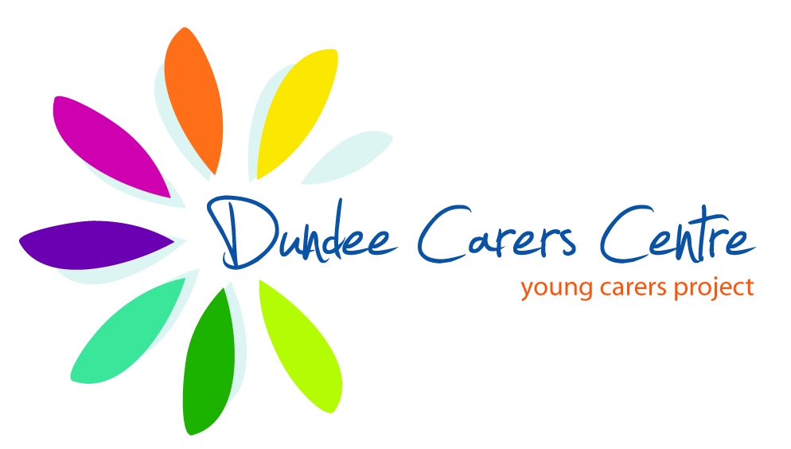 Upbeet conference follow-up questionnaire

Contact name: | Organisation:
Tel: | Email:

Yes |  | No
Do you currently work with young adult carers?
Yes |  | No

Are you planning to develop a service for young adult carers?

Which model do you think would best describe your practice (or planned service)?
(see overleaf for descriptors)
Keep in touch |  | Partnership – YCP ‘reaching up’
Teenage transition support |  | Partnership – adult service ‘reaching down’
Specialist 18+ service |  | Volunteer
16+ (16-25) |  | Pick and mix
Adult service responsibility |  | Other (give details)

How has your attendance at the Upbeet conference impacted on your practice?
Please tell us: ___________________________________________________________
______________________________________________________________________

Would you be interested in sharing examples/case studies of good practice in working with this age group? Yes, I have examples to share ___
Yes, I would like to learn from others’ practice ___ No, I am not interested ___

Is there any training or capacity building which you would find useful in relation to working with young adult carers?
Please specify: __________________________________________________________
______________________________________________________________________

Yes |  | No
Would you be interested in participating in a proposed national working group specific to young adult carer services?

Models of Emerging Service Responses
(adapted from Becker and Becker, 2008)

‘Keep in touch’
Young carers project ceases to provide a young carers service beyond the age of 18, but offer the young adults the opportunity to ‘keep in touch’ should they need to do so.

‘Teenage transition support’
Young carers project provides group support or dedicated worker to assist 16-18 year olds with issues of transition, signposting and supporting young people to re-engage with education, training or employment.

‘Volunteer’
Young carers project offers those over 18 the opportunity to volunteer with them, allowing a link to be maintained.

‘18+ specialist support service’
Projects with specific funding for a worker to support young adult carers aged 18-24 years – to enhance confidence and self-esteem and to help access employment, training or education.

’16 plus (16-25)’
Projects offer their ‘plus’ service to young carers aged 16 upwards in an attempt to keep those who are outgrowing young carers provision engaged and take them through to age 25.

‘Partnership’
Partnership approach between an adult carers service ‘reaching down’ and a young carers project ‘stretching up’ to jointly deliver support to young adult carers.

‘Adult services responsibility’
Young adult carers can access the support of adult carers services, though age-appropriate activities may or may not be provided.

‘Pick and mix’
Young adult carers access support or advice from a range of services, depending on their needs.

